A. A. Milne Elementary School
Shanta’ N. Creeks (Principal)
Houston Independent School District
7800 Portal Dr., Houston, TX 77071
Phone: 713-778-3420 Fax: 713-778-3424
@AAMilneE
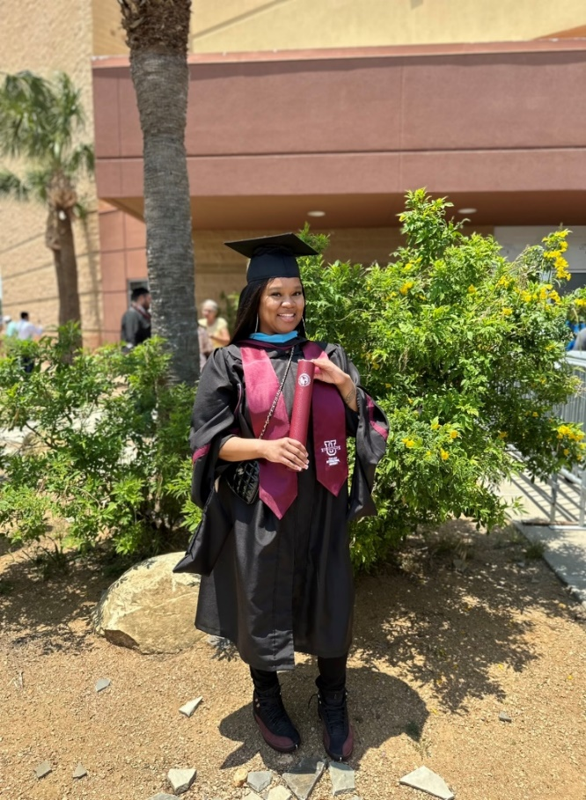
My name is Morgan Mosley, and I am so excited to be the school counselor at Milne Elementary School! I have been with HISD for three years as a 6th and 8th grade RLA Teacher. I graduated from Texas A&M International University with a Master’s degree in School Counseling. I also have a Bachelor's of Business Administration from Prairie View A&M University.
My job at Milne is to make sure that all of our students are academically and socially successful, not only here at school, but also in their personal home life. I work with students, teachers, administrators and parents to create a positive school experience and ensure our students strive to be their best selves every day. I truly believe that being a school counselor is the best job on earth and love every minute of it.
Individual Counseling
All students must deal with difficult issues sometimes during their school career. These concerns sometimes include conflicts with other students as well as stressful family changes. The counselor is here to help students work through individual problems they may be facing in order to help them be successful here at school.
Group Counseling
Group counseling provides a unique opportunity for students to be encouraged by others at the same age who are facing similar problems. Counseling groups are offered according to the needs of students and may include such issues as bullying, divorce, grief, self-esteem and friendship.
Classroom Guidance Lessons
The most effective way to meet the needs of the greatest number of students is through providing classroom guidance lessons. These lessons may be led by the counselor or the classroom teacher. They include topics that are relevant to the entire school population, such as character education, conflict resolution skills, career development, studying, test-taking skills and drug prevention.

